TASK 3:
class Solution {
public int[] runningSum(int[] nums) {

int[] result = new int[nums.length];
int sum = 0;

for (int i = 0; i < nums.length; i++) {
sum = sum + nums[i];
result[i] = sum;
}

return result;
}
}
Case 1:
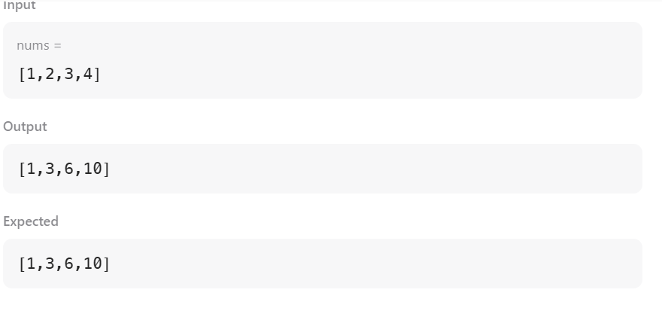
Case 2: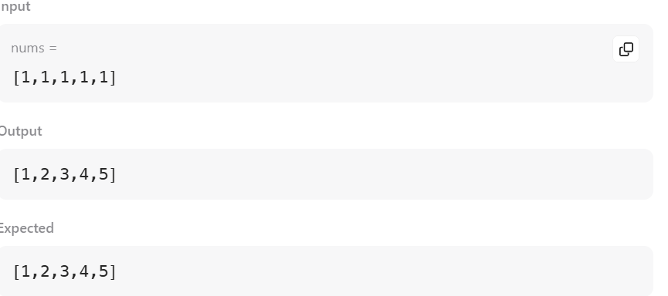

Case 3:
